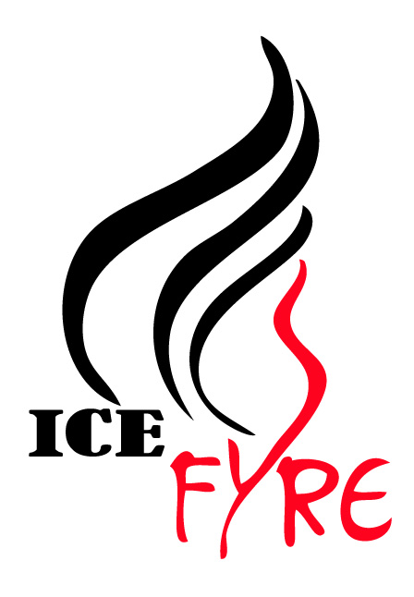2018-2019 Youth Team Auditions

Name: Click here to enter text.
Skate Canada #: Click here to enter text.
Skating Club: Click here to enter text.
Date of Birth: Day/Month/Year: Click here to enter text.
Address: Click here to enter text.
Email address: Click here to enter text.
Phone # Click here to enter text.
Parent / Guardian Name (if skater is under 18 years) Click here to enter text.
Last Skill Level (Last Passed) - Click here to enter text.
CanSkate 1, CanSkate 2, CanSkate 3, CanSkate 4, CanSkate 5, CanSkate 6, Pre-Preliminary (Star 1), Preliminary (Star 2 & 3), Jr Bronze (Star 4 & Star 5), Sr Bronze, Jr Silver, Sr Silver, Gold

Is this your first year for synchronized skating? YES ___ or NO ___
If NO, please fill in the following

Recent Synchronized Skating Experience
Year | Club / Team & Level
2017-2018 | Click here to enter text.
2016-2017 | Click here to enter text.

Audition:
Beginner / Pre-Juvie ($30) _____
Juvie/Pre-Novice ($40) _____
Intermediate ($40) _____

WSST Use Only (cheques payable to WSST) Board Member Initial _____
Amount Received $______________ Date: ___________________
Paid by: Cash _____ Cheque _____ Skater Account Credit _____

Ice Fyre
Whitby Synchronized Skating Teams
Placement Sessions

Acknowledgement

In consideration of participating in the Ice Fyre Placement Sessions and understanding that there are inherent risks of injury with skating and ice-related activities, the participant, parents or legal guardians agree that Ice Fyre, the Whitby Synchronized Skating Teams, Whitby Figure Skating Club and/or its Executive Committee / Board of Directors will not be held responsible for any loss or accident however caused.

The participating skater agrees to release the Whitby Figure Skating Club, Ice Fyre, the Whitby Synchronized Skating Teams, and their Board of Directors / Executive Committee, respectively, from all claims or damages which may arise as a result of or by reasons of such accident or loss. The participant (and participant’s parents or legal guardians) also agree to abide by the rules and policies of the Whitby Synchronized Skating Teams and Whitby Figure Skating Club.

I am of lawful age and legally authorized and competent to sign this release. I understand and fully agree to the conditions herein provided.

Participant’s Name (printed): Click here to enter text.
Parent/Legal Guardian’s Name (printed): Click here to enter text.
Parent / Legal Guardian’s Signature: __________________________________
Date: Click here to enter a date.

