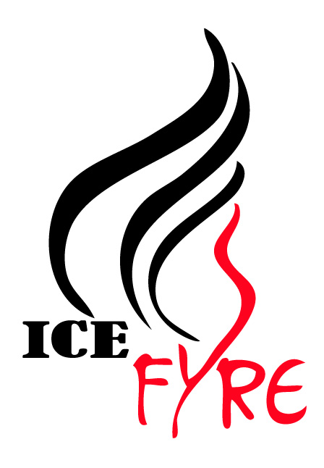Free Try Synchro Event
March 8, 2018 from 7PM – 8 PM

Name: __________________________________________________
Skate Canada #: __________________________________________
Skating Club _____________________________________________

Date of Birth: Day______ Month_________ Year_________
Address: ________________________________________________
Email address: ___________________________________________
Phone #_______________________
Parent / Guardian Name (if skater is under 18 years) ___________________

Skill Level / Badge (Last Passed)
_____ CanSkate 1 _____ CanSkate 2
_____ CanSkate 3 _____ CanSkate 4
_____ CanSkate 5 _____ CanSkate
_____ Pre-Preliminary (Star 1) _____ Preliminary (Star 2 & 3) _____ Jr Bronze (Star 4 & Star 5) _____ Sr Bronze
Other (please specify) ______________________

Ice Fyre Auditions for the 2018/2019 teams will be held on March 25th and April 8th. Skate times based on team audition. The audition fee covers both tryout days.

A signed waiver on the back of the form is required.

Ice Fyre
Whitby Synchronized Skating Teams
Try Synchro Waiver

Acknowledgement

In consideration of participating in the Ice Fyre Try Synchro Event and understanding that there are inherent risks of injury with skating and ice-related activities, the participant, parents or legal guardians agree that Ice Fyre, the Whitby Synchronized Skating Teams, Whitby Figure Skating Club and/or its Executive Committee / Board of Directors will not be held responsible for any loss or accident however caused.

The participating skater agrees to release the Whitby Figure Skating Club, Ice Fyre, the Whitby Synchronized Skating Teams, and their Board of Directors / Executive Committee, respectively, from all claims or damages which may arise as a result of or by reasons of such accident or loss. The participant (and participant’s parents or legal guardians) also agree to abide by the rules and policies of the Whitby Synchronized Skating Teams and Whitby Figure Skating Club.

I am of lawful age and legally authorized and competent to sign this release. I understand and fully agree to the conditions herein provided.

Participant’s Name (printed): ________________________________________
Parent/Legal Guardian’s Name (printed): _______________________________
Parent / Legal Guardian’s Signature: __________________________________
Date: _________________________

